Ford-Fulkerson Algorithm

Initialization: Start with 0 flow

Augmenting path: find an undirected path from s to t such that:

* Can increase flow on forward edges (not full)

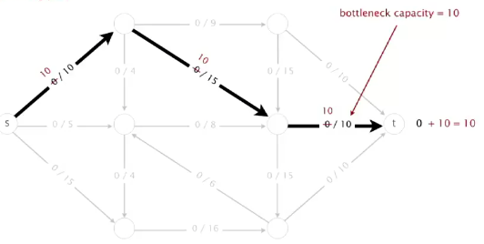

* + Simply continue in this way, finding a path
* Can decrease flow on backward edge (not empty)

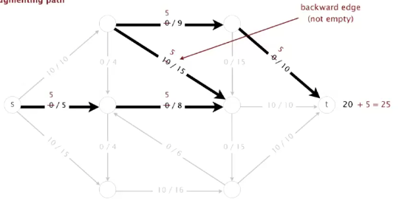

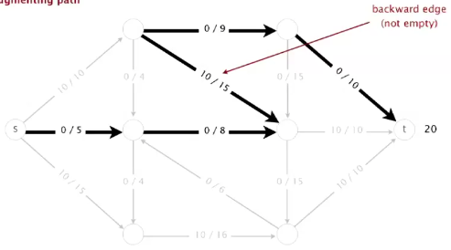

Termination: All paths from s to t are  blocked by either a

* Full forward edge or
* Empty backward edge

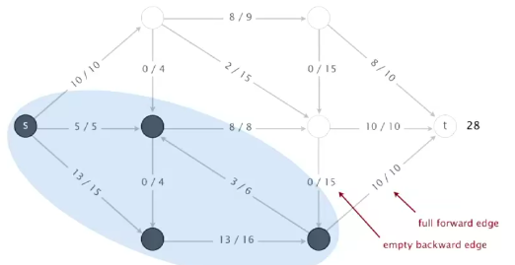

Ford-Fulkerson algorithm

Ford-Fulkerson algorithm

Start with 0 flow

While there exists an augmenting path:

* + Find an augmenting path
  + Compute bottleneck capacity
  + Increase flow on that path by bottleneck capacity

Questions:

* How to compute a mincut?
* How to find an augmenting path?
* If, FF terminates, does it always compute a maxflow?
* Does FF always terminate? If so, after how many augmentations?